**SayIT**

**Capstone Project Report**

**End-Semester Evaluation**

**Submitted by:**

**(101553008) Sanket Bansal**

**(101511058) Shivam Sah**

**(101503172) Pulkit Garg**

**BE Fourth Year, CSE**

**CPG No: 104**

Under the Mentorship of

Dr. Ashutosh Aggarwal

Assistant Professor



**Computer Science and Engineering Department**

**TIET, Patiala**

**November 2018**

**ABSTRACT**

There comes a time when a person haphazardly need to have a resolving conversation with someone (who is dealing with a quite similar situation) without being judged or having any fear of social defaming.

This project aims at providing a platform for the purpose of text counseling using chatbot. On chatting with the chatbot user data is sent to the trigger function which sends this data further to DialogFlow API and app engine running on Google Cloud Platform along with Firebase. Data is processed with tokenization, stop wards removal, stemming, term frequency-inverse document frequency, etc. This data is then pipelined to Indico.io API which uses recurrent neural networks and gives summary, sentiment, personality, part of speech tagging’s, etc. A document vector is then created which is compared with pre-processed data acquired through scrapping from various suicide forums out of which most relevant data in the form of document vector is retrieved and is sent to trigger script. Along with Google Cloud Platform data is also send to DialogFlow API which is mainly responsible for small talks and authentication of the user. DialogFlow response and document retrieved is analyzed and most relevant response for the input is sent to the user by the trigger script.

**DECLARATION**

We hereby declare that the design principles and working prototype model of the project entitled *SayIt* is an authentic record of our own work carried out in the Computer Science and Engineering Department, TIET, Patiala, under the guidance of Dr. Ashutosh Aggarwal during 7th semester (2018).

Date: November 16, 2018

|  |  |  |
| --- | --- | --- |
| **Roll No.** | **Name** | **Signature** |
| 101553008 | Sanket Bansal |  |
| 101511058 | Shivam Sah |  |
| 101503172 | Pulkit Garg |  |

*Counter Signed By:*

Faculty Mentor: Dr. Ashutosh Aggarwal

_________________________

Assistant Professor

Computer Science & Engineering Department,

TIET, Patiala

**ACKNOWLEDGEMENT**

We would like to express our thanks to our mentor Dr. Ashutosh Aggarwal. He has been of great help in our venture, and an indispensable resource of technical knowledge. He is truly an amazing mentor to have.

We are also thankful to Dr. Maninder Singh, Head, Computer Science and Engineering Department, entire faculty and staff of Computer Science and Engineering Department, and also our friends who devoted their valuable time and helped us in all possible ways towards successful completion of this project. We thank all those who have contributed either directly or indirectly towards this project.

Lastly, we would also like to thank our families for their unyielding love and encouragement. They always wanted the best for us and we admire their determination and sacrifice.

Date: November 16, 2018

|  |  |  |
| --- | --- | --- |
| **Roll No.** | **Name** | **Signature** |
| 101553008 | Sanket Bansal |  |
| 101511058 | Shivam Sah |  |
| 101503172 | Pulkit Garg |  |

**TABLE OF CONTENTS**

ABSTRACT i

DECLARATION ii

ACKNOWLEDGEMENT iii

TABLE OF CONTENTS iv

LIST OF TABLES viii

LIST OF FIGURES ix

LIST OF ABBREVIATIONS x

INTRODUCTION x

1.1 Project Overview x

1.2 Need analysis 3

1.3 Research Gaps 4

1.4 Problem definition 5

1.5 Assumptions & Constraints 5

1.6 Approved Objectives 5

1.7 Methodology 6

1.8 Project Outcomes And Deliverables 7

1.9 Novelty Of Work 7

REQUIREMENT ANALYSIS 7

2.1 LITERATURE SURVEY 7

2.1.1 Theory Associated With Problem Area 8

2.1.2 Existing Systems And Solutions 9

2.1.3 Research Findings for Existing Literature 10

2.2 STANDARDS 16

2.3 SOFTWARE REQUIREMENTS SPECIFICATION 17

2.3.1 Introduction 17

2.3.2 Overall Description 18

2.3.3 External Interface Requirements 19

2.3.4 Other Non-Functional Requirements 20

2.4 COST ANALYSIS 21

METHODOLOGY ADOPTED 22

3.1 INVESTIGATIVE TECHNIQUES 23

3.2 WORK BREAKDOWN STRUCTURE 25

3.3 TOOLS AND TECHNOLOGIES USED 25

DESIGN SPECIFICATIONS 26

4.1 SYSTEM ARCHITECTURE 27

4.2 DESIGN LEVEL DIAGRAMS 30

4.3 USER INTERFACE DIAGRAMS 31

IMPLEMENTATION AND EXPERIMENTAL RESULTS 33

5.1 EXPERIMENTAL SETUP (OR SIMULATION) 33

5.2 EXPERIMENTAL ANALYSIS 36

5.2.1 DATA 36

5.2.2 PERFORMANCE PARAMETERS 36

5.3 TESTING PROCESS 37

5.3.1 Test Plan 37

5.3.2 Test Cases 38

5.3.3 Test Results 39

5.4 RESULTS AND DISCUSSIONS 40

5.5 INFERENCES DRAWN 40

5.6 VALIDATION OF OBJECTIVES 41

CONCLUSIONS AND FUTURE DIRECTIONS 41

6.1 CONCLUSIONS 41

6.2 ENVIRONMENTAL, ECONOMIC AND SOCIETAL BENEFITS 42

6.3 REFLECTIONS 43

6.4 FUTURE WORK 44

PROJECT METRICS 46

7.1 CHALLENGES FACED 46

7.2 RELEVANT SUBJECTS 47

7.3 INTERDISCIPLINARY KNOWLEDGE SHARING 48

7.4 PEER ASSESSMENT MATRIX 49

7.5 STUDENT OUTCOMES DESCRIPTION AND PERFORMANCE 49

7.6 BRIEF ANALYTICAL ASSESSMENT 50

REFERENCES 52

PLAGIARISM REPORT 54

**LIST OF TABLES**

|  |  |  |
| --- | --- | --- |
| **Table No.** | **Caption** | **Page No.** |
| Table 1 | Software requirements.. | 19 |
| Table 2 | Cost analysis | 21 |
| Table 3 | Test set predictions for 4 second spectrogram | 38 |
| Table 4 | Test set predictions using majority vote | 39 |
| Table 5 | Peer Assessment Table | 48 |

**LIST OF FIGURES**

|  |  |  |
| --- | --- | --- |
| **Figure No.** | **Caption** | **Page No.** |
| Figure 1 | Diagram depicting overall data flow and subtasks of application | 2 |
| Figure 2 | For first quarter in the semester | 24 |
| Figure 3 | For second quarter in the semester | 24 |
| Figure 4 | Example of DialogFlow in action | 25 |
| Figure 5 | Client communication via GCP | 26 |
| Figure 6 | User authentication and management via Firebase | 27 |
| Figure 7 | Backend in action | 28 |
| Figure 8 | Overall Dialog-flow integration architecture | 29 |
| Figure 9 | Design level diagram | 29 |
| Figure 10 | User Interface Diagrams | 30 |
| Figure 11 | System Working Screenshots | 31 |
| Figure 12 | User Interface Design Blueprint | 32 |
| Figure 13 | Depressed percentage floating point | 33 |
| Figure 14 | ROC curve of the CNN model. | 38 |

**LIST OF ABBREVIATIONS**

|  |  |
| --- | --- |
| **GCP** | Google Cloud Platform |
| **API** | Application Programming Interface |
| **RNN** | Recurrent Neural Network |
| **NLP** | Natural Language Processing |
| **JSON** | JavaScript Object Notation |
| **NLTK** | Natural Language ToolKit |
| **Tf-Idf** | Term Frequency Inverse Document Frequency |
| **f-MRI** | Functional Magnetic Resonance Imaging |
| **CBT** | Cognitive Behavioural Therapy |

**INTRODUCTION**

* 1. **Project Overview**

Our application let user share their feeling and also try to calm user down with soothing text and also motivate the person and encourage to stay strong and carry on in life. The user can also enter a group chat dedicated to users going through the same problems in life where they can have a conversation with each other and open up about their feelings anonymously in a undeliberate and carefree manner.The chat group will be managed by a bot trained well aided through artificial intelligence especially for kind of situation, members of the group are in and try to create a group therapy session. If a person is too depressed then on user permission we will refer the case to a psychologist to get individual attention.

On chatting with the chatbot user data is sent to the trigger function which sends this data further to DialogFlow API and app engine running on Google Cloud Platform along with Firebase. Data is processed with tokenization, stop-words removal, stemming, term- frequency inverse-document-frequency, etc. this data is pipelined to Indico.io API which uses recurrent neural networks and gives summary, sentiment, personality, part of speech tagging’s, etc. and then document vector is created which is compared with pre-processed data acquired through scrapping from various suicide forums out of which most relevant data in the form of document vector is retrieved and is sent to trigger script.

Along with Google Cloud Platform data is also send to DialogFlow API which is mainly responsible for small talks and authentication of the user. DialogFlow response and document retrieved is analyzed and most relevant response for the input is sent to the user by the trigger script.

So, the chatbot conversation has following parts:

1. **Data acquisition**: In any machine learning based problem most important part of the solution is to acquire best possible data but in our case there was no relevant preprocessed data available on most of the well known NLP dataset websites so we have to rely on web scraping for data acquisition which we did using Beautiful Soup package from several suicidal and depression forums and made JSON file of the acquired data.
2. **Data pre-processing**: Data pre-processing was done using various methods:

* Tokenization: Data acquired is tokenized before processing this requires removal of punctuation marks and constituent words.
* Stop wards removal: Stop words from the dataset is removed these are words with high grammatical significance but no significance in overall meaning of sentence like is, will, it, etc. this is done using NLTK
* Stemming: Stemming needs to be done for reducing inflected (or sometimes derived) words to their word stem, base or root form.
* 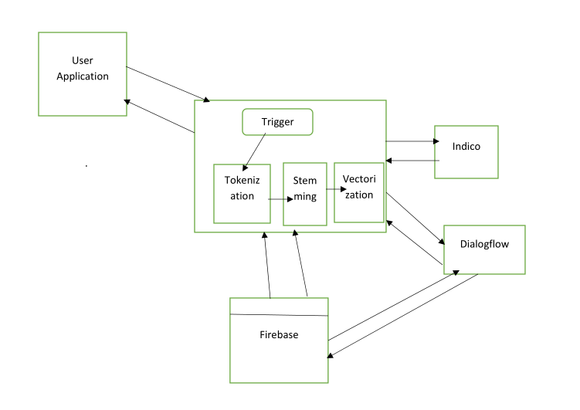Vectorization: We have used tf-idf vectorization to extract only those words which contribute more to overall meaning of sentences

Fig 1. Diagram depicting overall data flow and subtasks of application

1. **Processing Data**: We have used Indico.io API which uses recurrent neural networks and language models to process the data and gives us overall analysis of text data in JSON format this includes sentiment analysis, Part of Speech tagging, Personality, Relevance, Summarization, etc. this data is converted into document vectors and stored in firebase.
2. **Basic Chatbot tasks**: The parts like user authentication and small talks will be handles by DialogFlow API with customized intents and entities as required by us in the application.
3. **Trigger script**: This part of code is responsible for sending user data to DialogFlow and GCP App Engine performing above mentioned tasks and according to the output from both the system decide which output to send to the user.
4. **Relevant documents retrieval**: This is done by finding the cosine similarity between the new document formed by user input and pre-processed data.

As the figure 1. shows data of the user first goes to the trigger function for first time user authentication needs to be done so user data is transferred to firebase for authentication which is done with the help of dialoflow API which is programmed by us to accept user data and give appropriate responses by changing the intents and entities helping API models for training itself. Then after than user can chat with the chatbot each of the reply to be made is judged by the trigger function which makes weighted guess to predict which of the two results sent by DialogFlow and GCP is more relevant to the user query. Preprocessed dataset contains data of thousands of threads containing depressed user problem and solutions suggested by other users, dataset also contains motivational quotes and incidents for cheering up the person.

**1.2 Need analysis**

On day to day basis, we find ourselves surrounded by individuals, people we care about the most, people we admire and love, with these people we spend most of our time in sharing our feelings and creating memories. It’s been truly said that we can only be betrayed by whom we trusted most in those moments we sometimes find ourselves alone with no one to speak up our mind, many times we just don’t speak up our mind & self-pity due to hesitation and fear of being judged by another person, this leads to depression and other psychological anomalies after some-time of restrained emotions.

Not everyone experiences depression in the same way and for the similar reason.Some might not even realize that they are depressed, especially if they seems to other people as if they're managing their day-to-day life with ease. It doesn’t seem possible that someone can be smiling, chipper, functioning, and at the same time depressed due to which many a times depression remains undetected and without proper counseling and therapy.

Our application let user share their feeling and also try to calm user down with soothing text and also motivate the person and encourage to stay strong and carry on in life. The user can also enter a group forum dedicated to users going through the same problems in life where they can have a conversation with each other and open up about their feelings anonymously in a undeliberate and carefree manner.The chat group will be managed by a bot trained well aided through artificial intelligence especially for kind of situation, members of the group are in and try to create a group therapy session. If a person is too depressed then on user permission we will refer the case to a psychologist to get individual attention.

**1.3 Research Gaps**

The classification of depression (what types of depression exist) is a controversial issue that has led to a great deal of debate among psychiatry. This debate is important because if different types of depression exist, they can have different causes and results and respond to different treatments. Since, f-MRI (functional Magnetic Resonance Imaging) can predict precisely if depression exist or not, if in case, the interrogative techniques used here in the project fails. But, there is no such real-time methodolgy available for case specific distinction between depression’s various types.

Dispute arises because diagnoses are based simply on the presence of certain symptoms that are arbitrarily defined and generalized.

There is still no diagnostic depression test, such as a blood test or scan, that can confirm if someone has the disease.

This lack of an objective ' gold standard ' diagnosis means that doctors or any complex AI model do not know for sure whether the clusters of symptoms they use for diagnosis are valid or whether they deal with one or more diseases with the same low mood symptom.

There’s no clear difference in terms of features between anxiety, sadness, chronic-fatigue syndrome and, depression that will aid training of unsupervised clustering techniques.

**1.4 Problem definition**

Often times we find ourselves lonely and dull when we have no idea whats happening in our life, what to do next and, how to have motivation in facing the challenges. We are ashamed of sharing our feellings even to our known special/trusted friends due to fear of ridicule and embarrasement. We keep those feeling to ourselves and it gradually accumulates and turns out to be a massive. If at that point reservoirs are not open, results could be catastrophic. This situation can be surpassed via usage of our app.

**1.5 Assumptions & Constraints**

* The customer must have active high speed internet connection ~128 KB/s and, android smartphone with Android 5.0 or above.
* Thapar Institute of Engineering and Technology has agreed to fund around 4K-5K(if needed) for the project with a proper reimbursement process where the team will have to spend money on project and later team will submit their authorized bills to attain the reimbursement.
* As our college has high-end computation power technology and has access to very fast GPUs to work on, we assume that we will get the permission to use these computers for training our models with lesser time.
* The technology used in this project must be compatible to the platform of most of the user-base so that there are no issues.
* Just after the launch of the project’s app, an adequate accumulation of user-base data is required for accurately training the machine-learning model in the cloud.
* Since, we are lauching the app in the basic-version of Google cloud Platform (GCP) for their App-Engine and Cloud Storage, the constraint will not let channelize a high traffic rate through our servers.

**1.6 Approved Objectives**

* Chat application between user and chatbot
* Analyzing user mental condition through chat
* Feed for users on the basis of mental conditions and tags selected.
* Anonymous chat between user to user and user to group.
* Group video chat feature.
* Depression prediction using CNN via voice-timbre spectograms preprocessed through DAIC_WOZ database

**1.7 Methodology**

**Recurrent neural networks**: Recurring neural networks are a class of artificial neural networks in which connections between nodes form a focused graph along the sequence. This allows him to present a dynamic time behavior of the time series.

**Stemming**: In the language morphology and retrieval of information, the root is the process of reducing the vocabulary, vocabulary or root form of vocabulary, vocabulary or root form. The stem does not have to be identical to the morphological root of the word; in general it is sufficient to map the relevant words on the same trunk, even if the trunk itself is not a valid root. Search engines usually use stems to index words. The search engine does not store all word forms, only the stems, which significantly reduces the index and improves the accuracy of retrieval. One of the most common extraction algorithms is the Porter rod algorithm by Martin Porter. It is designed to remove and replace familiar English suffixes.

**Vectorization**: In terms of vectorization it is important to remember that it is not just about converting a single word into a single number. Although words can be converted to numbers, the entire document can be converted to a vector. Vectors can not only have multiple dimensions, but vectors for text data are generally large. This is because each dimension of the entity data is a single word and the language of the document being examined contains thousands of words.

They are of several types:

* **Count vectorizer**: Takes any mass of text and returns each unique word as a feature with the count of number of times that word occurs.
* **TF-IDF**: It reveals what words are the most discriminating between different bodies of text. It is particularly, helpful if you are trying to see the difference between words that occur a lot in one document, but fail to appear in others allowing you interpret something special about that document. It is dependent on term frequency, how often a word appears, and Inverse document frequency, whether it is unique or common among all documents.

**1.8 Project Outcomes And Deliverables**

The application will be free of cost available on Google play store to all the users. We will start with the version that will be “open source” under GNU General Public License version 2 (GPLv2) on which any developer can work and help improve the overall performance of the App. It will be a free code. The changes made by developers will be implemented only if they help app improving its performance and better functionality. The enhanced versions will be sent to user as updates.

**1.9 Novelty Of Work**

We have hereby laid extra emphasis on the use of Distress Analysis Interview Corpus (DAIC) (Gratch et al.,2014) dataset, that contains clinical interviews designed to support the diagnosis of psychological distress conditions such as anxiety, depression, and post-traumatic stress disorder. The scrapping of Suicide Forum [a] is done to get dataset for tags classification model. A mere another existing depression-based chatbot is WoeBot made under guidance of Andrew-Ng which uses methods from Cognitive Behavioral Therapy (CBT).



**REQUIREMENT ANALYSIS**

**2.1 LITERATURE SURVEY**

**2.1.1 Theory Associated With Problem Area**

Emotion Analysis (SA) is an ongoing field of research in the field of text mining. Emotions Analysis is a computer study about the opinions, attitudes and emotions of a person. Entity can represent individuals, events or subjects. There are three main classification levels in a SA: document level, sentence level, and aspect level. At the document level, SA aims to classify a thought document as expressing a positive or negative thought or emotion. He sees the document as a whole, a basic information unit (talking about a subject). The SA at the sentence level aims to classify the emotions expressed in each sentence. The classification of texts at the level of the document or sentence does not provide the necessary details for all aspects needed in many applications, it is necessary to proceed to the aspect level in order to obtain these details. The purpose of the SA dimension is to classify emotion in relation to certain aspects of the entity.

Feature Selection methods can be divided into lexicon-based methods that need human annotation, and statistical methods which are automatic methods that are more frequently used. Lexicon-based method have many difficulties as reported by Whitelaw et al.

The techniques of classifying sentiment can be roughly divided into machine learning approaches, a lexicon-based approach and a hybrid approach (Diana Maynard, Adam Funk). Machine learning Method (ml) applies the famous ML algorithms and uses language elements. The lexicon-based approach relies on a lexicon of sentiment, a collection of well-known and precompiled conditions of sentiment. It is divided into a dictionary-based approach and a corpus-based approach that use statistical or semantic methods to find the sentiment of polarity. The hybrid approach combines both approaches and is very common with the lexicons of sentiment plays a key role in most methods. The text classification methods using ML approach can be roughly divided into supervised and unsupervised learning methods.The approach based on lexicons depends on the opinion lexicon used to analyze the text. This approach contains two methods. The dictionary approach (Qiu and He), which depends on finding words for opinion, then searches the dictionary of their synonyms and antonyms. The corpus approach (Hatzivassiloglou and McKeown) begins with a seed list of opinions and then finds other opinions in a large corpus to help find opinions with contextual orientations. This can be done by statistical or semantic methods.

Recent work for handling virtual counselling session:

* Recent work by Kevin Clark and Tim Althoff [20] connected anyone in crisis to psychologist via text-messaging through a 24/7 helpline after the session each user received feedback questions about the service. Data collected from experiment was used to analyze effectiveness of text-based counselling over conventional counselling and it was found that text-based counselling is almost equally effective.
* Mitsuyoshi [19] suggested that there is a relationship between these feelings of pleasure / disappointment and different emotions and proposed a system that indicates anger, happiness, sadness and calm, as well as the degree of pleasure / disappointment, which means emotional intensity. Mitsuyoshi et al.’s model, which was used in the development of Sensitivity Technology (ST) Emotion by AGI Inc, has developed a technology to identify human emotions from prosodic information in speech. This device incorporates a solid fundamental frequency estimation technique and a if / then rule base derived from a massive emotion labeled speech database. ST detects more than 200 emotional parameters from spoken natural utterances and displays in real time the percentage of anger, happiness, sadness and calm contained in a person's speech based on the utterance frequency for these parameters and their speech patterns.

**2.1.2 Existing Systems And Solutions**

Most of the existing solutions are based on one to one chat between psychologists and user these applications use little to none machine learning and are charged heavily on the basis of psychiatrist and chat time. Woebot was recently developed by Stanford Ph.D. students with inputs from Andrew-Ng. This application is still in initial stage and have similar architecture but their data set is much better than theirs so their accuracy is better although no information of implementation or API’s was given on site except they have used dataset collected from real life patients and their interactions with actual psychologists.

There are various health chatbots available like Infermedica, Babylon Health, Bots4Health etc which asks patient about health condition and prescribe medicines on the basis of symptoms and patient’s medical history, they use hardcoded symptoms matching with user medical conditions to depict the possible illness. Most of these apps use little to no machine learning techniques in examining patient and diagnosis. They are not really accurate in complicated conditions and it’s always advisable to go to a real doctor in serious medical condition or if there is no sign of improvement in health after few days.

Dataset of most of the research in this subject was not provided and was obtained majorly by using human in the loop method using sites like crowdflower.

**2.1.3 Research Findings for Existing Literature**

|  |  |  |  |  |  |  |
| --- | --- | --- | --- | --- | --- | --- |
| Sr. No | Roll Number | Name | Paper Title | Tools/  Technology | Findings | Citation |
| 1. | 101553008 | Sanket | Sentiment Analysis for Depression Detection on Social Networks | Sina Micro Blog API,10 fold cross validation, Bayes model,  Waikato Environment for Knowledge Analysis(WEKA) for classification into depressed or normal | A model to detect depressed users in the social network based on sentiment analysis is proposed for approximately 80 percent accuracy. | [1] |
| 2. | 101553008 | Sanket | Emotion recognition on speech signals using machine learning | Random forest, gradient boosting, SVM, For feature extraction Mel Frequency Cepstral Coefficients  (MFCC)(Equation on Pitch and Loudness) and energy. | Audio signal classified in one of the seven classes: Neutral, Sad, Happiness, Anxiety, Disgust, Boredom, Anger. The random decision forest achieved the highest 81.05 percent accuracy | [2] |
| 3. | 101553008 | Sanket | Large-scale Analysis of Counselling Conversations: An Application of Natural Language Processing to Mental Health | TF_IDF vectorization,k-nearest neighbor(k=  10) | Developed a set of new computer discourse analysis methods for large - scale data sets and used them to discover actionable conversation strategies linked to better conversation results. | [3] |
| 4. | 101553008 | Sanket | Detecting Practical Speech Emotion in a Cognitive Task | Acoustic features are extracted for valence dimension and arousal dimension with voice quality features. For the recognition algorithm Gaussian Mixture Model is adopted for detecting each type of emotions from neutral speech. | The detection rate for anxiety and confidence is higher than 70.1 percent using a GMM-based classification. The method of correction of errors using the context information proposed in this paper improves by an average of 4.05 percent. | [4] |
| 5. | 101553008 | Sanket | Inferring Emotional Tags From Social Images With User Demographics | Three learning methods, namely, naive Bayesian (NB), support vector machine (SVM) and traditional factor graph model (FGM) | They investigated how demographics of users, such as gender, marital status and occupation, relate to social image emotional tags. To leverage uncovered patterns, a partially labeled factor graph model called the demographic factor graph model (D-FGM) is proposed. | [5] |
| 6. | 101553008 | Sanket | Angel-Echo: A Personalized Health Care Application | Bluetooth GATT Protocol, Amazon DynamoDB database, Angel sensor wristband | They propose a smart application that monitors health status by combining the data collection capabilities of the Angel sensor and the voice interfacing capabilities of the Amazon Echo. they also present test results of the Amazon Echo speech recognition on different demographic | [6] |
| 7. | 101511058 | Shivam | Stress Evaluation by voice: from prevention to treatment in mental health care | AGI Inc. Sensitivity Technology software. (ST) detects more than 200 emotional characteristic parameters from spoken natural utterances and GHQ-30 (General Health Questionnaire) based on the utterance frequency of these parameters and their voice patterns | Introduced a system for stress assessment using the technology for emotional recognition through speech. | [7] |
| 8. | 101511058 | Shivam | Natural language processing in mental health applications using non-clinical texts | Linguist Inquiry and Word Count (LIWC) software for extraction of features and SVM | The aim of the paper was to provide a taxonomy of how NLP was used in mental health applications and possible future integration opportunities in online mental health tools. | [8] |
| 9. | 101511058 | Shivam | Detection and Analysis of Emotion From Speech Signals | Mel Frequency Cepstral Coefficients  (MFCC)(Equation on Pitch and Loudness) and energy, WEKA software for classification | The paper examined the idea of detecting a person's emotional state using techniques for speech processing. It has been observed that in a speech segment there are distinguishable characteristics that characterize every emotional state. After the classification tests on a data set prepared by 30 subjects, it was observed that data from an individual subject is better considered than a group of people. | [9] |
| 10. | 101511058 | Shivam | Sentiment analysis and affective computing for depression monitoring | Beck Depression Inventory-II (BDI-II) and Patient Health Questionnaire (PHQ), Mel Frequency Cepstral Coefficients (MFCC), Data obtained from phone camera , messages and data from fitbit, various NLP techniques like stemming , lemmatization. Model used was Random Forest | For the monitoring of depression conditions preliminary design of an integrated multimodal system based on sentimental analysis and affective computing methodologies | [10] |
| 11. | 101511058 | Shivam | The Psychology of Word Use in Depression Forums in English and in Spanish: Testing Two Text Analytic Approaches | Linguist Inquiry and Word Count (LIWC) software, Meaning Extraction Method(MEM),Principal Component Analysis, Wordsmith software | Online deprimed writers used much more singular pronouns of the first person, less plural pronouns of the first person in both the English and Spanish forums. These findings supported the social engagement / depression model of depression (Durkheim 1951), which states that depressed people tend to concentrate and separate themselves from others. | [11] |
| 12. | 101511058 | Shivam | Emotion recognition in speech using MFCC and wavelet features | Mel-frequency Cepstral Coefficient (MFCC) and subband based Cepstral Parameter (SBC) method audio characteristics of emotional speech. In addition, the Gaussian Mixture Model (GMM) classifies these features. SAVEE audio database is used for testing in this work | The experimental results show that the SBC performance is better than MFCC. | [12] |
| 13. | 101503172 | Pulkit | Efficient  Recognition of  Human  Emotional  States from  Audio Signals | 7 EmoDB data set discrete emotional states based on nineteen (19) audio features (15 standalone, 4 joint) using the Support Vector Machine (SVM) classification | As a result, the total accuracy of recognition achieved in the EmoDB data set for seven emotions is 83.33 percent compared to the basic accuracy of 72.22 percent. | [13] |
| 14. | 101503172 | Pulkit | Affective Image Classification using Features Inspired by Psychology and Art Theory | Three data sets are used: the International Affective Picture System (IAPS); a set of artistic photo sharing tools (to investigate whether the artists ' conscious use of colors and textures improves classification); and a set of peer-rated abstract paintings to investigate the influence of features and ratings on images without contextual content. | In comparison with state-of - the-art work, improved classification results are obtained in the International Affective Picture System (IAPS). | [14] |
| 15. | 101503172 | Pulkit | Integrating Deep and Shallow Models for Multi-Modal Depression Analysis — Hybrid Architectures | The proposed hybrid framework consists of three main parts: 1) A (DCNN) and (DNN) multi - modal audiovisual depression recognition based on (PHQ-8) scale; 2) A Paragraph Vector (PV) and (SVM) model based on transcript physical and mental conditions | The proposed hybrid framework effectively improves both depression estimation and depression classification accuracy with an average F1 measure of up to 0.746, which is higher than the best result (0.724) of the AVEC2016 depression subchallenge. | [15] |
| 16. | 101503172 | Pulkit | A neural network diagnostic tool for the chronic fatigue syndrome | Patients with chronic fatigue syndrome (CFS) have complex patterns of multiple and variable (non-consistent) psychiatric and somatic symptoms classified by CNN based on self-report questionnaire | The neural network has clearly distinguished patients with CFS, patients with major unipolar depression, lipid patients and healthy control groups. | [16] |
| 17. | 101503172 | Pulkit | Video-Based Depression Level Analysis by Encoding Deep Spatiotemporal Features | A new framework is proposed to estimate the Beck Depression Inventory II (BDI-II) values from video data that automatically learn spatiotemporal features on two different face scales using a 3D neural network, Model used RNN-C3D | Experiments on the AVEC2013 and AVEC2014 depression data sets show that the approach proposed is promising compared with the latest visual depression analysis methods. | [17] |
| 18. | 101503172 | Pulkit | A Realistic Chat Environment for Virtual Avatars in Cyber Space | A single greedy algorithm to find an optimal 3-D virtual space position that optimizes the availability of chat. Our system reconstructs a dialog graph that maintains all transcripts in the form of temporal (dialog sequences) and spatial information (physical positions) about communicating agents. | This paper proposes a unified communication framework in a virtual world for multiple avatars (e.g. second life). | [18] |

**2.2 STANDARDS**

Standards used for the proposal design solution while developing the prototype were as follows:

1. IEEE 1471: It is the IEEE standard for software/system architecture according to which the entire architecture of our working prototype was designed.
2. IEEE 1233: IEEE standard for system requirement specifications. It was followed while preparing the SRS document for this system, which is a structured collection of information that embodies the requirements of a system.
3. IEEE 830: IEEE standard for specifying system requirements. It has been used to create the SRS document for this system. The Software Requirements Specification describes a software system to be developed and sets out functional and non - functional requirements and includes a set of user cases that describe the user interaction a software needs to provide.
4. IEEE 1016: It is the IEEE software design standard. A description of the software design is a written description of a software product that describes the entire project architecture. A SDD usually accompanies an architectural diagram with detailed descriptions of smaller design pieces. The standard was followed when specific system details such as a data flow diagram were described.

**2.3 SOFTWARE REQUIREMENTS SPECIFICATION**

**2.3.1 Introduction**

**2.3.1.1 Purpose**

The purpose of this project was to diagnose and depict depression in an individual and provide him with necessary medium so that he can speak of his problem without fear of getting judged and ridiculed. Application also lets user share their feelings to other users so they do not feel that they are facing the problems alone. Users can also share words of wisdom of how the themselves tackled the depression helping others in coming out of phase too.

**2.3.1.2 Intended Audience**

The problem was designed keeping in mind that user can be depressed and in that case patience becomes an important factor so the app is really easy to use features are easy to find overall app can be easily navigated through. Application can also be used by an individual not depressed but feeling lonely and is in a need of companion to share his feelings.

**2.3.1.3 Project Scope**

SayIT is android application which helps depressed or an companionless person by providing an chat assistant which can talk to the user like a real friend consolidate, motivate and help fight the depression and sadness felt by the user.

**2.3.2 Overall Description**

**2.3.2.1 Product Perspective**

Under the general GNU public license, the product should be an open source. It's a web - based system that implements the client-server model. The SayIt system provides users with a simple mechanism to share their perspective on problems and solutions.

The following are the main features that are included in the package:

* Cross platform support: Provides operational assistance for most known and commercial operating systems.
* User account: The system enables the user to create their account in the system and provide update and view profile features.
* Number of users the system supports: Although the number is not precisely specified, many online users can be supported at once.
* Tags Selector: Tags Selector is just a local keyword search engine.
* Discussion Forum: Provides users with a platform to talk about their problems and help each other
* FAQs section: The FAQ section contains the often faced problem response of the user.

**2.3.2.2 Product Features**

1. **User Stories**: user can write their own stories using texts, pictures and emojis on the web editor (what you set is what you get editor) .And just after publishing the post, AI aided tags will be automatically generated to categorize that post and will appear in user’s custom RSS (Rich Site Summary; originally RDF Site Summary; often called Really Simple Syndication) feed tab.
2. **Anonymous Texting** : chatting can be done to other users by searching their username and requesting for a chat session.
3. **Tag based Chat feature** : we added a special new feature to the text mode, the option to input "interest" tags. Adding interests lets users be paired with a stranger who has something in common with the user. A user can input as many interests as he or she would like, and if no available match is found, the user is paired with a completely random stranger instead.
4. **Psycho Therapy session** : The interpretation of people's responses via aid of machine learning model which will originally base upon [psychoanalytical theory](https://en.wikipedia.org/wiki/Psychoanalytical_theory) .When this chatbot is used empirically, the quality of the responses related to the measurements of personality is increased gradually. And, we will use this chat bot model to participate in a virtual therapy session to guide the user about the problem discussed so far.

**2.3.3 External Interface Requirements**

**2.3.3.1 User Interfaces**

* Authenticate user interface : User should be authenticated by their phone number. Unique username is used for user profile for maintaining anonymity.
* Chat bot counselling interface: Depict level of depression in user, motivate user to move on, suggest chat groups with participants facing similar situation.
* Private chat request: Users can chat personally with their friends using personal chat on this interface (it’s not recommended to reveal your real name during chat)
* Topics of interest: Users can select topics tags of interest on this interface and their feed will get updated with those topics as users post them.
* Motivational Feed: Followed topics will be updated here, it will contain content to motivate and inspire user and also help him cope up with the situation.

**2.3.3.2 Hardware Interfaces**

The recommendation is to have at least 1 GB of RAM, 1.6 GHz Processors-clock frequency, ~100 MB free storage. The Project requires a [32-bit](https://en.wikipedia.org/wiki/32-bit) [ARMv7](https://en.wikipedia.org/wiki/ARMv7), [MIPS](https://en.wikipedia.org/wiki/MIPS_architecture) or [x86](https://en.wikipedia.org/wiki/X86) architecture processor (latter two through unofficial ports), together with an [OpenGL ES](https://en.wikipedia.org/wiki/OpenGL_ES) 2.0 compatible [graphics processing unit](https://en.wikipedia.org/wiki/Graphics_processing_unit) (GPU). Android supports OpenGL ES 1.1, 2.0, 3.0, 3.1 and as of latest major version, 3.2 and since Android 7.0 [Vulkan](https://en.wikipedia.org/wiki/Vulkan_(API)) (and version 1.1 available or some devices)

**2.3.3.3 Software Interfaces**

We currently support the following android versions with their corresponding API levels:

**Table 1 Software requirements**

|  |  |  |  |  |
| --- | --- | --- | --- | --- |
| **Code name** | **Version number** | [**Linux kernel**](https://en.wikipedia.org/wiki/Linux_kernel) **version** | **Initial release date** | **API level** |
| [KitKat](https://en.wikipedia.org/wiki/Android_version_history#Android_4.4_KitKat_(API_19)) | 4.4 – 4.4.4 | 3.10 | October 31, 2013 | 19 – 20 |
| [Lollipop](https://en.wikipedia.org/wiki/Android_version_history#Android_5.0_Lollipop_(API_21)) | 5.0 – 5.1.1 | 3.16 | November 12, 2014 | 21 – 22 |
| [Marshmallow](https://en.wikipedia.org/wiki/Android_version_history#Android_6.0_Marshmallow_(API_23)) | 6.0 – 6.0.1 | 3.18 | October 5, 2015 | 23 |
| [Nougat](https://en.wikipedia.org/wiki/Android_version_history#Android_7.0_Nougat_(API_24)) | 7.0 – 7.1.2 | 4.4 | August 22, 2016 | 24 – 25 |
| [Oreo](https://en.wikipedia.org/wiki/Android_version_history#Android_8.0_Oreo_(API_26)) | 8.0 – 8.1 | 4.10 | August 21, 2017 | 26 – 27 |
| [Pie](https://en.wikipedia.org/wiki/Android_version_history#Android_9.0_Pie_(API_28)) | 9.0 | 4.4.107, 4.9.84, and 4.14.42 | August 6, 2018 | 28 |

**2.3.4 Other Non-Functional Requirements**

**2.3.4.1 Performance Requirements**

The app must be highly optimized to

* Use resources sparingly and don’t consume much battery power.
* Start up quickly and no lag is observed.
* Respond quickly to user interaction and should not be prone to any glitch.

**2.3.4.2 Security Requirements**

User is advised to use Oauth2.0v of google instead of normal email- login system in app to avoid any sort of leakage of user personal device’s sensory data or cyber-crime through cracked username and password.

Oauth2.0v: OAuth allows third - party services such as Twitter to use the account information of an end - user without disclosing the user's password. OAuth acts as an mediator on behalf of the end user, provides the service with an access token that allows the sharing of specific account information. A flow is called the process for obtaining the token.

User is advised to not reveal any private data to prevent any misuse and, thus keep their anonymity intact.

As the base for a mobile computing environment, the Linux kernel provides Android with several key security features, including:

* A user-based permissions model
* Process isolation
* Extensible mechanism for secure IPC
* The ability to remove unnecessary and potentially insecure parts of the kernel

We use these features for android to make the app more secure and isolated by third-party applications.

**2.4 COST ANALYSIS**

**Table 2 Cost analysis**

|  |  |  |
| --- | --- | --- |
| **Product** | **Unit Cost** | **Total Estimated Cost** |
| Compute Engine | ₹180/month | ₹2000 |
| App Engine | ₹30/month | ₹500 |
| Cloud Storage | ₹50/month | ₹150 |
| Total expense |  | ₹2650 |

**METHODOLOGY ADOPTED**

**3.1 INVESTIGATIVE TECHNIQUES**

|  |  |  |  |
| --- | --- | --- | --- |
| **S. No.** | **Investigative Projects Techniques** | **Investigative Techniques Description** | **Investigative Projects Examples** |
| 1 | Descriptive | 1. An ink blot test is a general test category. Interpretations of ambiguous stimuli in projective tests are used to analyze inner thoughts, feelings and personality traits. In the early 1920s, Herman Rorschach created the first systematic ink blot test of his kind that interpreted the personality characteristics of test subjects. His test was popular but also reportedly criticized. Several other ink blot tests were formed after his death. Some of these new tests are: Howard Ink Blot Test and Holtzman encryption technique.  2. DAIC-WOZ DataSet :  This database is part of a larger body, the Distress Analysis Interview Corpus (DAIC) (Gratchet al.,2014), which includes clinical interviews designed to diagnose psychological distress conditions such as anxiety, depression and post - traumatic stress disorder. | Actually ink blots were used in the 19th century for a game called " Blotto. "  The Howard ink blot test has participants answering with the ink blots on one card at a time.  Kykiefer (Data Scientist and, Chemical Engineer @San Francisco, CA, USA) proposed a project ( initial commit - July’17 ) that Predicts depression from acoustic features of speech using a Convolutional Neural Network. |
| 2 | Comparative | CBT is based on the concept that your thoughts, feelings, physical sensations and actions are interconnected, and that negative thoughts and feelings can trap you in a vicious cycle. CBT has been shown to be an effective way of treating several different mental health conditions.  In addition to depression or anxiety disorders, CBT can also help people with:   * obsessive compulsive disorder (OCD) * panic disorder * post-traumatic stress disorder (PTSD) * phobias * eating disorders – such as anorexia and bulimia * sleep problems – such as insomnia | Woebot.io lets you think through situations with step-by-step guidance via using Cognitive Behavioral Therapy (CBT) |
| 3 | Experimental | Sensibility Technology software by AGI Inc.( ST) detects more than 200 emotional parameters from spoken natural utterances and for these parameters and their speech patterns based on the utterance frequency.  ) | “[Feasibility Study of Evaluation of Therapeutic Effect for Sleep Apnea Syndrome Using Mental Healthiness Evaluated from Voice](https://www.researchgate.net/publication/325452833_Feasibility_Study_of_Evaluation_of_Therapeutic_Effect_for_Sleep_Apnea_Syndrome_Using_Mental_Healthiness_Evaluated_from_Voice)”  A Conference Paper in [IFMBE proceedings](https://www.researchgate.net/journal/1680-0737_IFMBE_proceedings) · June 2018 [DOI: 10.1007/978-981-10-9038-7_165](http://dx.doi.org/10.1007/978-981-10-9038-7_165)  Conference: Conference: IUPESM World Congress on Medical Physics and Biomedical Engineering 2018 (IUPESM 2018) |

**3.2 WORK BREAKDOWN STRUCTURE**

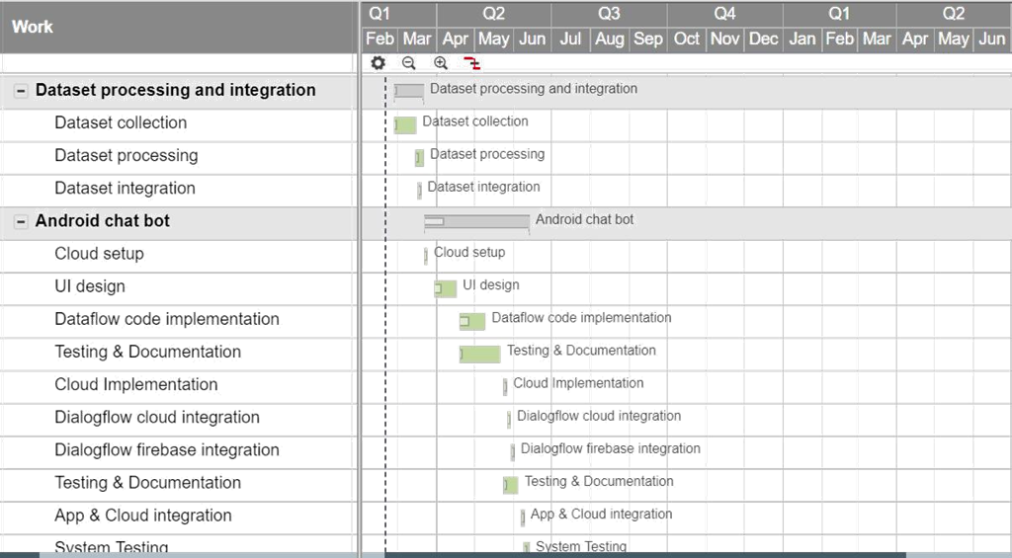

-

Fig 2. For first quarter in the semester

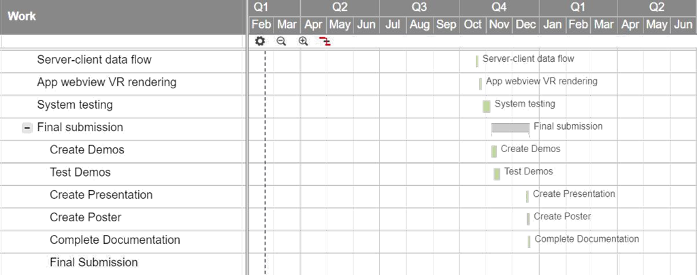

Fig 3. For second quarter in the semester

**3.3 TOOLS AND TECHNOLOGIES USED**

**DialogFlow** : DialogFlow is a Google acquired system for human–computer interaction using natural language conversations. The company is best known for creating assistant, a virtual chat and voice-based bot for Android and iOS smartphones that performs tasks and answers user’s natural language-based queries. DialogFlow has also developed a natural language processing engine that includes a conversation context such as dialog history, location and user preferences.

The process a DialogFlow agent follows from invocation to fulfillment is similar to someone answering a question.

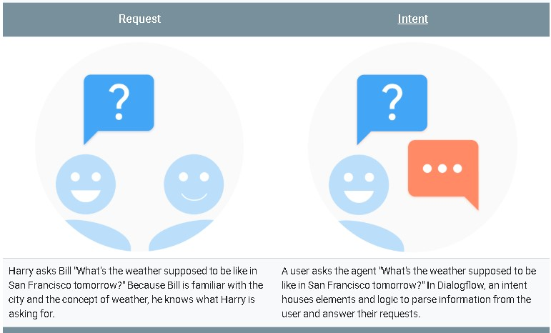

Fig 4. Example of DialogFlow in action

**Indico.io** : Indico is an NLP based API which uses various machine learning and statistical models to provide optimized and accurate processed data containing more than 15 information like sentiment, part of speech, personality, summary ,etc.it also provides API for image processing and analysis.

Processed data output from this API is very accurate and is used by top companies like hyperplane, Boston Speed capitals,etc.

**DESIGN SPECIFICATIONS**

**4.1 SYSTEM ARCHITECTURE**

**Client-communication**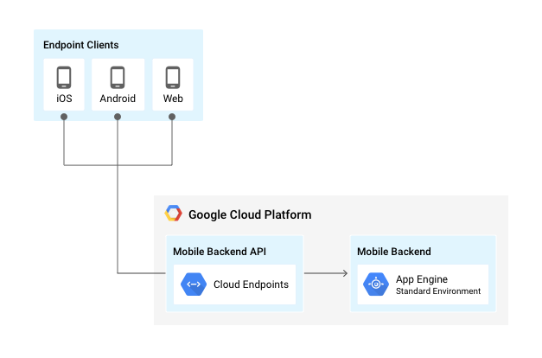

Fig 5. Client communication via GCP

* User gets connected to the App engine using cloud endpoints created after deployment these endpoints are used to access different services over the server.
* App engine after receiving requests through these endpoints perform data manipulation and computation send back the response through these cloud endpoints

**User authentication and management**

* In firebase we will be using cloud firestore to store user’s data such as preferences, profile name , keywords, current health status in documents format
* Also firebase will be used for real-time notifications and cloud messaging.
* User Authentication is the important part of application which will be handled through firebase authentication.

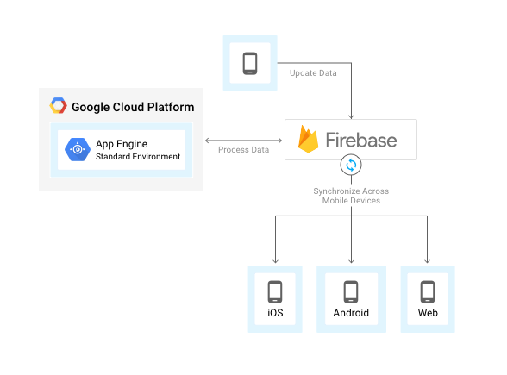

Fig 6. User authentication and management via Firebase

**App Backend**

* Here Cloud storage is used to store images and positives quotes which will be tagged with words and their confidence score using computer vision and natural language processing concepts.
* Quotes we will be tagged in various categories based on the words used inside it such as depression, anxiety, love relationship, sexuality etc.

Images will be tagged with words such as sadness, happiness, anger, and then these tags will be matched with the tags of the user’s post to provide relevant quotes and images.

* Compute engine will deal with the processing and storage of scrapes data which includes various articles. Each article will be considered as a document in our database. A document will pass through the natural language processing pipeline created over compute engine using which documents will be preprocessed and attached with various tags and entities.
* After processing documents each tags and entity will work as a metadata for the article which will be used during information retrieval.
* All the meta data will be attached to the document in json format and stored on cloud datastore. Cloud pub/sub will be used for managing workers attached with app engine which will do backend synchronization and management.

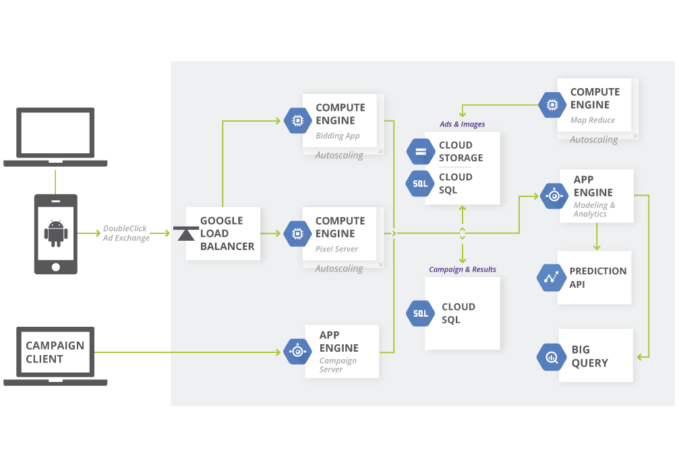

Fig 7. Backend in action

**Dialog-Flow & Cloud-Function**

* Dialog-Flow is a Google acquired system for human–computer interaction using natural language conversations. The company is best known for creating assistant, a virtual chat and voice-based bot for Android and iOS smartphones that performs tasks and answers user’s natural language-based queries.
* Dialog-flow will be used for creating rule-based design of chat bot it will detect the various entities and intents inside the query send by the user and the used rule-based flow diagram to provide response.
* Cloud functions will work as a webhook which will be called whenever the query comes for Dialog-flow it will manipulate the query to get different responses through Dialog-flow such as fulfillments.

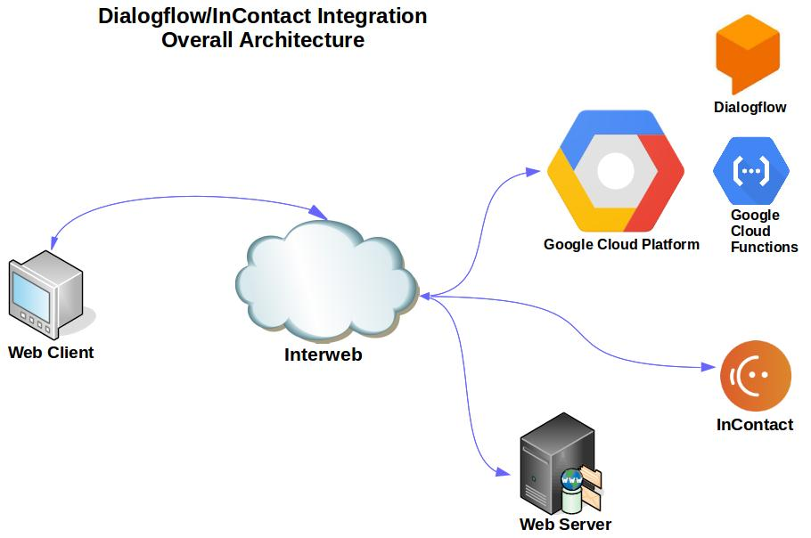

Fig 8. Overall Dialog-flow integration architecture

**4.2 DESIGN LEVEL DIAGRAMS**

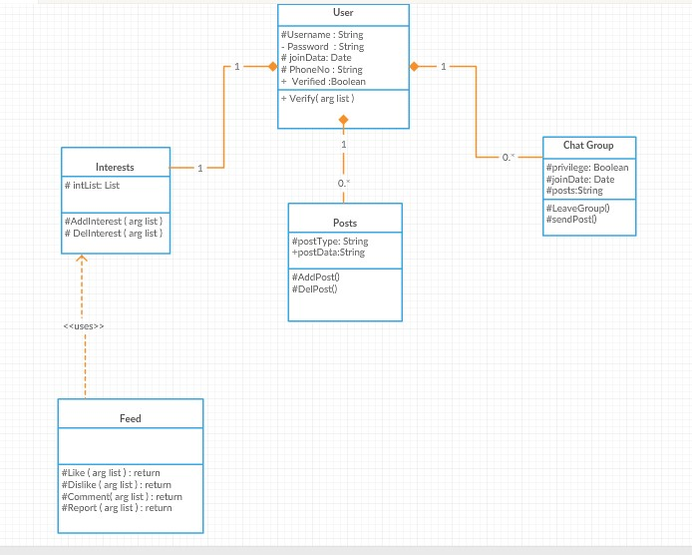

Fig 9. Design level diagram

**4.3 USER INTERFACE DIAGRAMS**

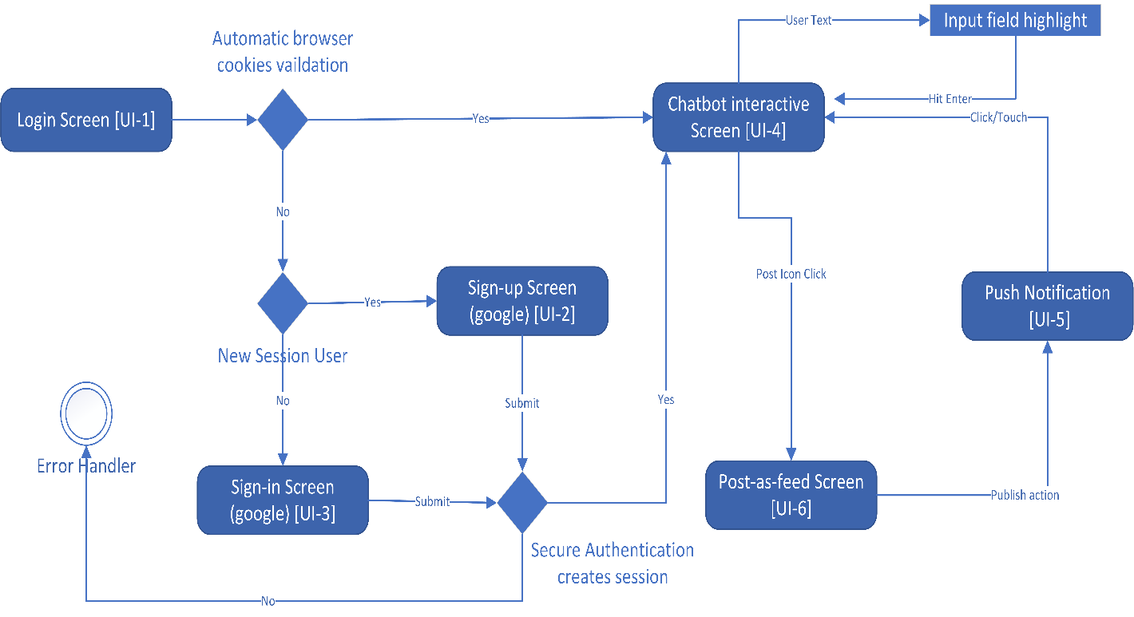

Fig 10. User Interface Diagrams

**4.4 SYSTEM SCREENSHOTS**

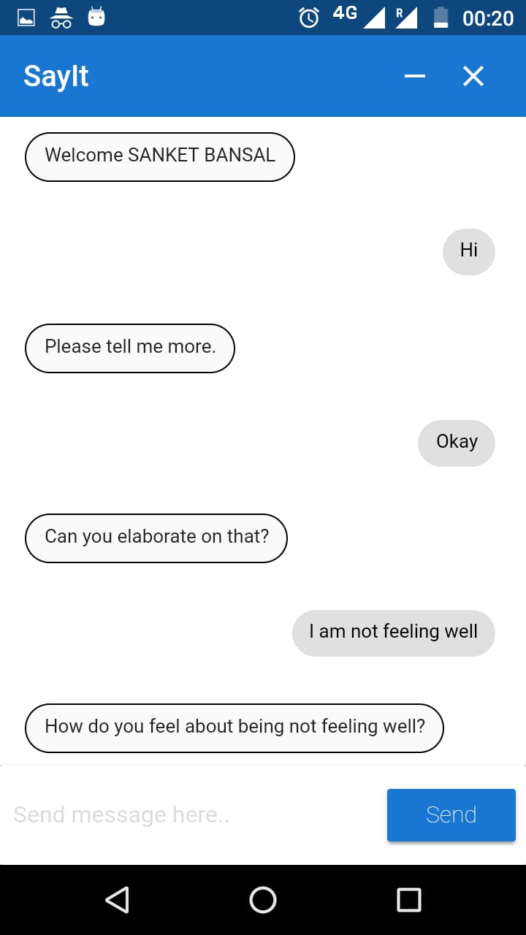 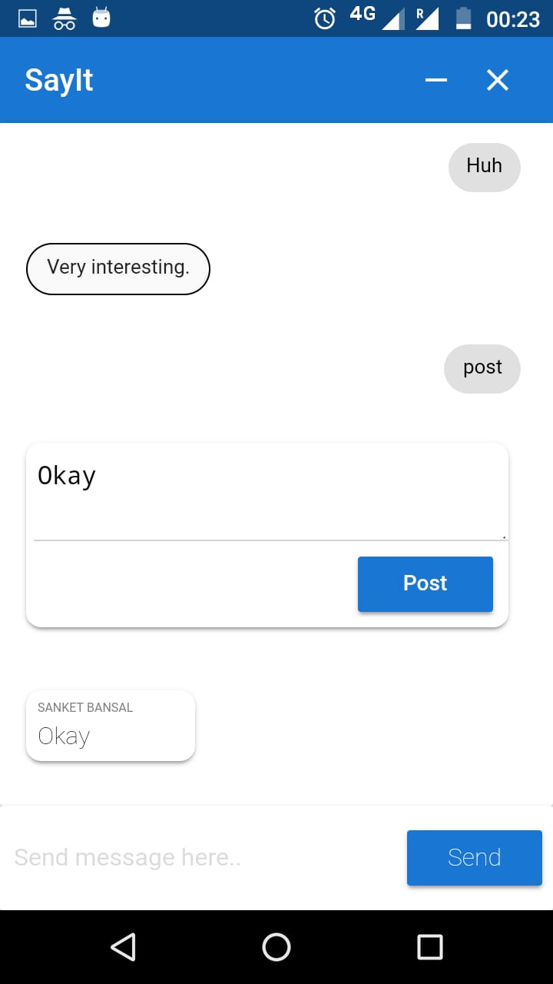

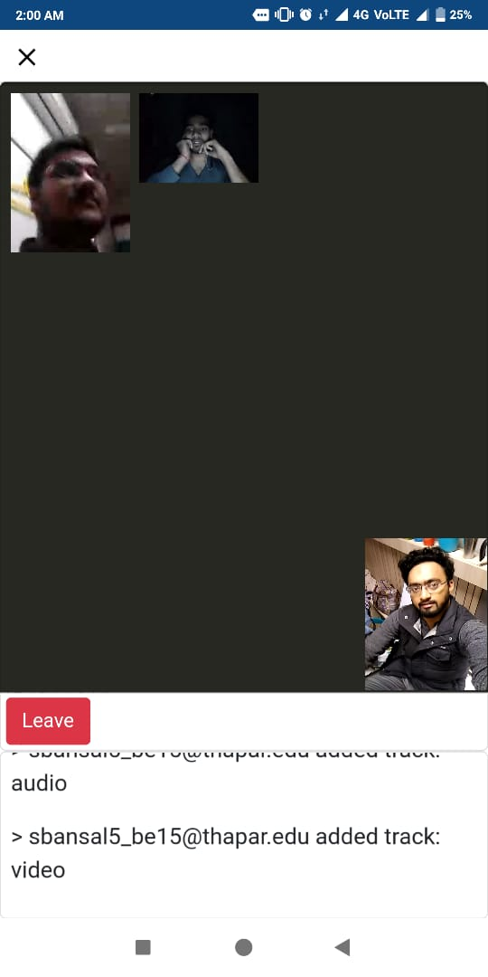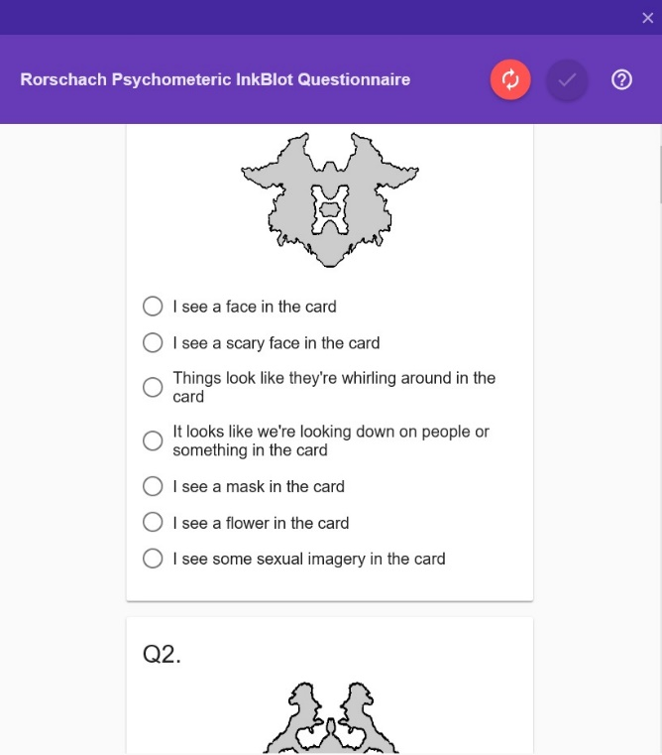

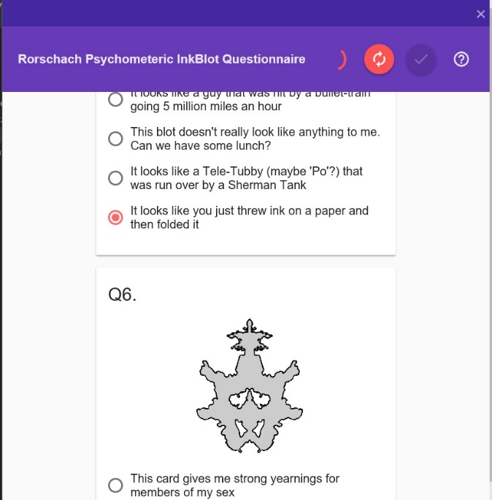 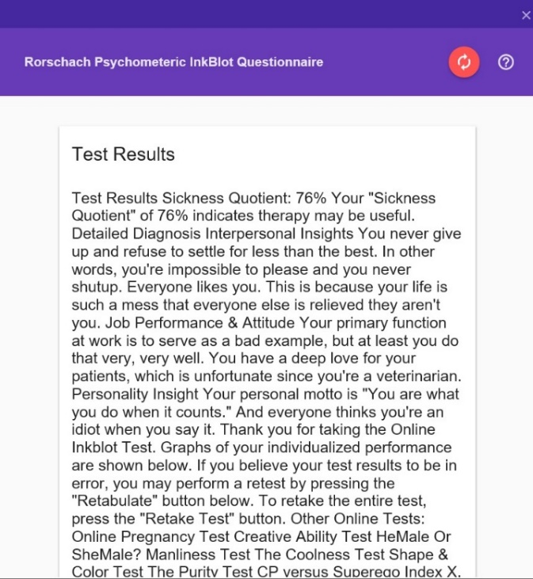

Fig 11. System Working Screenshots

**IMPLEMENTATION AND EXPERIMENTAL RESULTS**

**5.1 EXPERIMENTAL SETUP (OR SIMULATION**)

**User Interface**

Software developed is Progressive Web App (PWA) which means it is an hybrid app made using web app technologies like HTML, CSS and JavaScript but still can support native environments like of Android and IOS. Speciality of these apps are they are always device compatible, optimized and can work offline any web app can be transformed to PWA by importing a set of libraries and following bunch of rules.

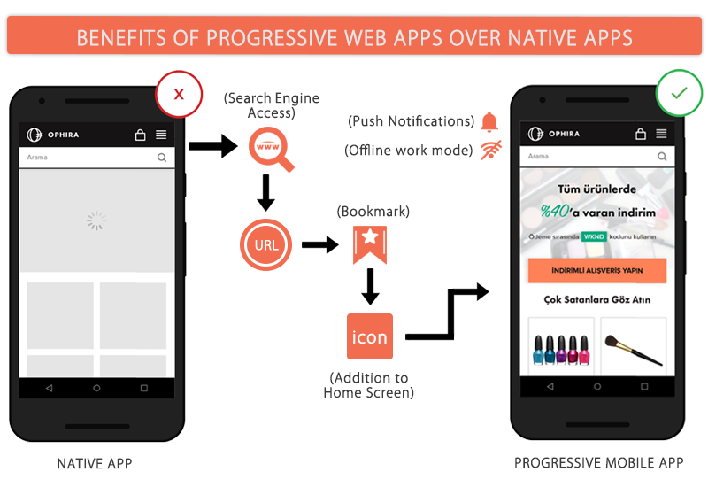

Fig 12. User Interface Design Blueprint

**Backend Design**

**Model :**

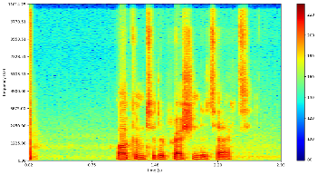

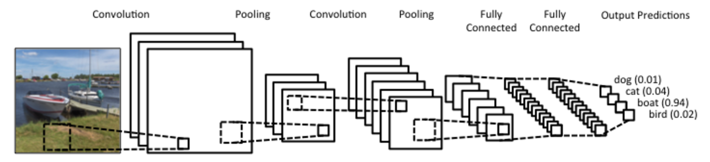

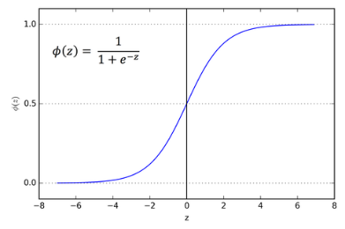

Fig 13. Depressed percentage floating point

CNNs take images as input. In the case of the spectrogram We pass a grayscale representation, with the "greyness" representative of the audio power level at that specific frequency and time.

A filter (kernel) is subsequently slid over the spectrogram image and patterns for depressed and non-depressed individuals are learned (based on the aforementioned "truth" dataset).

The CNN begins by learning features like vertical lines, but in subsequent layers, begins to pick up on features like the shape of frequency-time curve (perhaps representative of speaker intonation). Such learned features may provide an elegant and powerful representation of different prosodic features of speech, which in turn are representative of underlying differences between depressed and non-depressed speech.

However, with the highly detailed representations of speech provided in spectrograms, false noise signals (ambient noise, plosives, unsegmented audio from other speakers, etc.) can be inconveniently picked up by the network. One can mitigate this noise with different regularization parameters in the network (pooling layers, L1 loss functions, dropout, etc)

**Model Setup :**

We created the model using [*Keras*](https://keras.io/)with a [*Theano*](http://deeplearning.net/software/theano/) backend and trained it on an AWS (student waive account) GPU-optimized EC2 T1.medium instance with a Static-Ip for consistency across the Devices and the Service APIs for clients are secured via *SHA-512/224 -key* authentication.

The CNN used here begins with an input layer being convolved with 32-3x3 filters to create 32 feature maps followed by a ReLU activation function. Next, the feature maps undergo dimensionality reduction with a max-pooling layer, which uses a 4x3 filter with a stride of 1x3.

A second similar convolutional layer is employed with 32-3x3 filters followed by a max-pooling layer. This layer is then followed by two dense layers. After the second dense layer, a *dropout* layer of 0.5 is used.

Lastly, *a softmax function* is applied, which returns the probability that a spectrogram is in the depressed class or not depressed class. The sum probabilities of each class is equal to a batch size of 32 (out of 2480 spectrograms) was used along with an *Adadelta* optimizer, which dynamically adapts the learning rate based on the gradient.

**Training and Setup :**

The model was trained on 40 randomly selected 513x125 (frequency x time bins) audio segments from 31 participants in each category of depression (resulting in 2,480 spectrograms in total). This is representative of just under 3 hours of audio in order to adhere by strict class (depressed, not depressed) and speaker balancing (160 seconds per subject) parameters. The model was trained for 7 epochs, after which it was observed to overfit based on train and validation loss curves.

**5.2 EXPERIMENTAL ANALYSIS**

**5.2.1 DATA**

All audio recordings and associated depression metrics were provided by the [DAIC-WOZ Database](http://dcapswoz.ict.usc.edu/). The Database was compiled by USC's Institute of Creative Technologies and released as part of the 2016 Audio/Visual Emotional Challenge and Workshop. The dataset consists of 189 sessions, averaging 16 minutes, between a participant and virtual interviewer called Ellie, controlled by a human interviewer in another room via a "[Wizard of Oz](https://en.wikipedia.org/wiki/Wizard_of_Oz_experiment)" approach. Prior to the interview, each participant completed a psychiatric questionnaire from which a binary "truth" classification (depressed, not depressed) was derived.

**Data Setup :**

We, firstly acquired the permission and respective Basic Auth. - Credentials via agreement send to *boberg@ict.usc.edu.* Now, we downloaded the DAIC-WOZ database into S3 Standard-Storage Class via running a python37 script which kept running for 48-corn-hours on EC2 t2.micro instance. It used BOTO3 library and, Beautiful Soup4 for scraping the zip-links from *indexof/ apache http-file sever* page. There were a total of 195 *.zip files aggregating to 85.7 GB. The chunk size is 64 MB for Stream Transfers.

**5.2.2 PERFORMANCE PARAMETERS**

1. The speech as given by the user, should not contain any sort complex sarcasm and, metaphoric or hidden meanings. This reduces the ability of the Machine Learning model to predict as desired with less noise and error tolerance.
2. Deep learning models are typically trained by a stochastic gradient descent optimizer. There are many variations of stochastic gradient descent: *Adam, RMSProp, Adagrad,* etc. All of them let you set the learning rate and frequency as required to train the model. This parameter tells the optimizer how far to move the weights in the direction opposite of the gradient for a mini-batch. If the learning rate is low, then training is more reliable, but optimization will take a lot of time because steps towards the minimum of the loss function are tiny.
3. SMS language is English language slang, used as a means of mobile phone text messaging. A survey done in South California indicated that majority of educators viewed SMS language as having a negative influence on the transmission of exactness and accuracy of information thus conveyed. Slang are not that consistent with their actual meanings which gets continuously and persistently changed with time and different context.
4. The background ambience for extracting acoustic features of speech must be crystal clear and should be free be from any spatial distortion or pressure clicks/pops.

**5.3 TESTING PROCESS**

**5.3.1 Test Plan**

**5.3.1.1 Features to be tested**

The foremost main objective to test is the backends Convolutional Neural Network (CNN) design that predicts whether a user has depression or not. The other elements such as user interfaces are supplementary for testing purposes and, are thus not included. The AUC (area under curve for Receiver operating characteristic) accuracy and Predictability of the machine learning model thus deployed, constitutes the major and most fundamental part of the project.

**5.3.1.2 Test Strategy**

The test-cases (extracted randomly from DAIC-WOZ Dataset, as mentioned in test-techniques column) are feeded directly into Convolutional Neural Network using Amazon S3’s BOTO Storage client for Python37. A test-script is deployed to a very new Amazon ec2 t1 microVM instance and batch training is done through the service APIs provided by the backend server. The results, thus obtained are reproduced as python matplotlib graphical representation.

**5.3.1.3 Test Techniques**

In the current dataset, the number of non-depressed subjects is about four times larger than that of depressed ones, which can introduce a classification "non-depressed" bias. Additional bias can occur due to the considerable range of interview durations from 7 to 33 minutes, because a larger volume of signal from just one individual may emphasize some characteristics that are person specific.

To curb there issues out, techniques used are:

1. Each of the participant's segmented spectrograms were cropped into 4-second slices. Next, participants were randomly sampled in 50/50 proportion from each class (depressed, not depressed). Then, a fixed number of slices were sampled from each of the selected participants to ensure the CNN has an equal interview duration for each participant. This drastically reduced the training dataset size to 3 hours from the original 35 hours of segmented audio, which was felt adequate for this exploratory analysis.
2. A majority vote across the 40 spectrograms per participant is explored to predict each participant’s depression category. However, only 14 users is contained in the test set (in order to maximize the training data), As might be expected, model evaluation statistics will improve somewhat when taking a majority vote. However, the sample size is quite small.
3. We assessed our model and tuned our hyperparameters based on [AUC score](https://en.wikipedia.org/wiki/Receiver_operating_characteristic#Area_under_the_curve) and F1 score on a training and validation set. AUC scores are commonly used to evaluate emotion detection models, because precision and recall can be misleading if test sets have unbalanced classes.

**5.3.2 Test Cases**

The test set (which is distinct from the train and validation sets used to develop the model) was composed of 560 spectrograms from 14 participants (40 spectrograms per participant, totaling 160 seconds of audio). Initially, predictions were made on each of the 4-second spectrograms, to explore the extent to which depression can be detected from 4-second audio segments. Ultimately, a majority vote of the 40 spectrogram predictions per participant was utilized to classify the participant as depressed or not depressed.

**5.3.3 Test Results**

**Table 3:** Test set predictions for 4 second spectrogram

| **Confusion Matrix** | **Actual: Yes** | **Actual: No** |
| --- | --- | --- |
| **Predicted: Yes** | 174 (TP) | 106 (FP) |
| **Predicted: No** | 144 (FN) | 136 (TN) |

| **F1 score** | **Precision** | **recall** | **accuracy** |
| --- | --- | --- | --- |
| 0.582 | 0.621 | 0.547 | 0.555 |

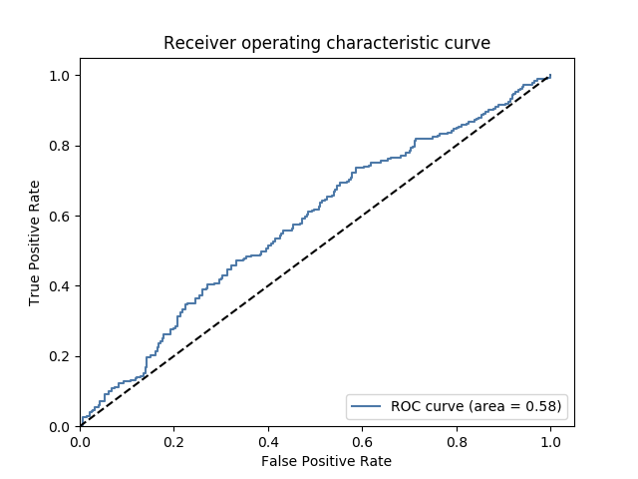

**Figure 14:**ROC curve of the CNN model.

**Table 4:** Test set predictions using majority vote

| **Confusion Matrix** | **Actual: Yes** | **Actual: No** |
| --- | --- | --- |
| **Predicted: Yes** | 4 (TP) | 2 (FP) |
| **Predicted: No** | 3 (FN) | 5 (TN) |

| **F1 score** | **Precision** | **recall** | **accuracy** |
| --- | --- | --- | --- |
| 0.615 | 0.667 | 0.571 | 0.643 |

**5.4 RESULTS AND DISCUSSIONS**

Automatic Depression Detection (ADD) is a relatively nascent topic that first appeared in 2009. State of the emotion detection models exhibit AUC scores ~0.7 (our model had an AUC score of 0.58), utilizing the lower level features alluded to. Although, this rapidly developed model is not yet at a predictive state for practical usage "as is", these results strongly suggest a promising, new direction for using spectrograms in depression detection.

**5.5 INFERENCES DRAWN**

This initial model provides a solid foundation and promising directions for detecting depression with spectrograms. Further work should train in more speakers. Low level audio transformations do a good job of reducing the noise in the data, which allows for robust models to be trained on smaller sample sizes. However, I still hypothesize they overlook subtleties in depressed speech.

We would prioritize future efforts as follows:

1. Sampling methods to increase training size without introducing class or speaker bias would be a prioritize task in the future releases.
2. Treating depression detection as a regression problem.
3. Introducing network recurrence ([LSTM](http://blog.echen.me/2017/05/30/exploring-lstms/)).

Depression moves across a spectrum, so deriving a binary classification (depressed, not depressed) from a single test (PHQ-8) is somewhat naïve and perhaps unrealistic. The threshold for a depression classification was a score of 10, but how much difference in depression-related speech prosody exists between a score of 9 (classified as not depressed) and a 10 (classified as depressed)? For this reason, the problem may be better approached by using regression techniques to predict participants' PHQ-8 scores

**5.6 VALIDATION OF OBJECTIVES**

|  |  |  |
| --- | --- | --- |
| **S. No.** | **Objectives** | **Status** |
| 1 | Chat application between user and chatbot | Successful |
| 2 | Analyzing user mental condition through chat | Successful |
| 3 | Feed for users on the basis of mental conditions and tags selected. | Successful |
| 4 | Anonymous chat between user to user and user to group. | Successful |
| 5 | Group video chat feature. | Successful |
| 6 | Depression prediction using CNN via voice-timbre spectograms preprocessed through DAIC_WOZ database | Successful |

**CONCLUSIONS AND FUTURE DIRECTIONS**

**6.1 CONCLUSIONS**

According to the Centers for Disease Control and Prevention (CDC), 7.6 percent of people over 12 years of age have depression over a period of 2 weeks. This is important and shows the scale of the problem.

Depression is the world's most common disease and the main cause of disability, according to the World Health Organization (WHO). It is estimated that 350 million people worldwide are affected by depression.

Every time a suicide news comes out, we ask the same questions. What leads a person to end his or her life? Why do they not seek help? They don't think about families and friends? And more. And more. But the most important question is what we can do to help. The answer is often that you listen to the distressed and help them in their struggle without judgment. The reasons may vary, but people are often led to disastrous decisions because they are lonely and unable to find help.

Our objective of making this project was to help the community by making a chatbot which anyone can talk to, share their feelings, thoughts, sorrow and pain. Chatbot listens to the user and gives avid responses and calm user down. User can see the depression related posts of other users using the app which will make him feel that he is not the only one facing problems in his life and get motivation to come out of the phase.

Treating depression is an area under active research a lot of work is still required to properly understand the conditions of brain in the depression and how it is different from anxiety and sadness. Maybe soon we will be able to devise better methods to classify these different feelings and then better machine learning models can be developed.

**6.2 ENVIRONMENTAL, ECONOMIC AND SOCIETAL BENEFITS**

1. The free counselling service provides quality mental-health care with no cost, to the non-elite community which tests for mental-illness vulnerability and want to check if the problem even exists or not before flinging up money unboundedly into hoaxed doctor advices and path-laboratory tests. Quite often , the doctors over-exaggerate in terms of severity of the problem. These, make the naïve patients spend much more charges into unassociated tests and pave the way for direct commissions to the doctor from the testing laboratories.
2. On day to day basis, we find ourselves surrounded by individuals, people we care about the most, people we admire and love, with these people we spend most of our time in sharing our feelings and creating memories. It’s been truly said that we can only be betrayed by whom we trusted most in those moments we sometimes find ourselves alone with no one to speak up our mind, many times we just don’t speak up our mind & self-pity due to hesitation and fear of being judged by another person, this leads to depression and other psychological anomalies after some-time of restrained emotions.
3. Not everyone experiences depression in the same way and for the similar reason. Some might not even realize that they are depressed, especially if they seems to other people as if they're managing their day-to-day life with ease. It doesn’t seem possible that someone can be smiling, chipper, functioning, and at the same time depressed due to which many a times depression remains undetected and without proper counseling and therapy.

**6.3 REFLECTIONS**

1. Teamwork is absolutely necessary when you’ve got several people working for a common goal because people have different skills, different approaches, different capacities to focus. They need to know what they excel at and let the others take charge in situations that are beyond their ability/control. Certainly, vanity can get in the way, but a good leader should know how to combine their efforts and help them take the front scene of their area of expertise. The truth is team success is more rewarding than individual success. This project helped us in aligning our thought process and abstract ideas to achieve a specific goal. This project would not have been possible unless each of team members had given appropriate and much needed contribution.
2. We tended to break product development work into small increments that minimize the amount of up-front planning and design. Small time frames that typically last from one to four weeks were given like a burst time to each feature. At the end of the iteration our working prototype was demonstrated to the mentor for feedback and dev-ops alike paradigm. This minimizes overall risk for time and workforce wastage and, allows the product to adapt to changes quickly without going into irrelevant direction.
3. An inference is drawn and discovered by all of our team-mates originally and separately. This conclusion is so far not to use and deploy any unpopular open-source library or binaries without proper validation and testing of all its modules. GitHub Inc. and bitbucket are full stack of piles which contains public repositories that don’t work as intended or documented . Some libraries even don’t compile and, build properly that leads to further disappointments, One just must avoid visiting all these bloated unreliable codes and stick to high rating/stars repositories.
4. Modularity allows for the division of typical applications into modules and integration with similar modules, which helps developers to use pre - written code. The modules are divided on the basis of functionality and programmers do not participate in other modules ' functionality. New features can therefore easily be programmed into separate modules. In this project, we broke the structure with a predefined set of adapters and interfaces and, if necessary, REST service APIs. This also helps to eliminate all the difficulties in the testing and debugging phase.
5. Most important and fundamental of all, we learned new technologies such as cloud computing aided by *AWS* and *GCP , Keras – TensorFlow’s higher level API*, *Nodejs & angular.io* for progressive web apps. These upcoming techs are making their way into well established organizations and so will definitely help us in adapting to standard corporate tools. Also, we preferred popular and much promoted libs over undocumented ones to avoid any issues with code backward compatibility.

**6.4 FUTURE WORK**

1. Infermedica improves the diagnostic process with the most advanced reasoning technology for medical preliminary diagnosis. On the LinkedIn page of Infermedica, 26 professionals, including data scientists, are associated with the company. For example, the previous experience of data analytics and machine learning by data scientist Tomasz Smolarczyk includes positions in Proctor & Gamble and McKinsey & Company.

In 2017, Infermedica claims that it conducted “three million diagnostic interviews with patients” which contributed to an asymptotic rise in the accuracy of their chatbot. Infermedica can be integrated in our project for medical advisory and prescription purposes. The application has been approved to us for the developer usage of its API.

1. Sensitivity Technology (ST) allows you to automatically analyze the complex feelings of humans from your voice regardless of a word or individual differences. By using ST, the complex feelings of humans can be visualized quantitatively by colours. Detailed psychological analysis and behavioral action prediction can be carried out by examining the real - time analysis of the pronunciation by the results of ST's colors and feelings.

The results of the fMRI experiment showed a correlation of 99.9 percent accuracy between the output of ST analysis and the affective (emotional) brain activity. ST analysis corresponds to the feelings of the speaker, exceeding the subjectivity of the third party in the comparative experiment.

We can use the technology to improve the accuracy of our project’s chatbot in analysing behavioural and emotional hints from the user to assess the depression state and the kind of psychological/ psychiatric disorder corresponding to user tendencies.

1. Up till now, the concept of majority vote and, bagging – boosting (*XGBoost, LightGBM, CatBoost*) across various other applicable machine leaning models has not been yet done. Models such as *GMM ( Gaussian Mixture Model ) , random forest, SVM (support vector machine), naïve Bayesian model* etc.
2. After incrementation in user database through usage of our progressive web-app, we can improve the accuracy of our chatbot although it requires some more dynamics in dropout layers and *ReLU* layers to allow more data so that it won’t overfit the model. The data would be kept on AWS economic-storage classes to ease modularity for such added functionality of feedback training.

**PROJECT METRICS**

**7.1 CHALLENGES FACED**

1. A foremost uncanny challenge is faced by all of our team-mates originally and separately. This conclusion is so far not to use and deploy any unpopular open-source library or binaries without proper validation and testing of all its modules. GitHub Inc. and bitbucket are full stack of piles which contains public repositories that don’t work as intended or documented . Some libraries even don’t compile and, build properly that leads to further disappointments, One just must avoid visiting all these bloated unreliable codes and stick to high rating/stars repositories.
2. Many companies and organizations does provide various service APIs that are used for our project. Getting access to those API’s credentials key for authentication purposes is really time taking and all the transactions or communications done between us and the organization were through email merely. And one can’t expect a spontaneous/quick response without skidding the application through weeks or sometimes even months.
3. We use Amazon Web Services and google cloud platform together due to migration problems through various clouds. Since, to apply no funds required for development policy, we need to shut off VM-instance / lambda functions / app-engines / Kubernetes engine, if not in frequent use to avoid automatic recurring costs applied to our student accounts affiliated to thapar.edu domain name.
4. The topic we choose for our capstone project was a little different and therefore it required a lot of time devotion but due to the placements procedures that have their own critical and classical emphasis over data structures and algorithm foundations and, the academic curriculum still in progress, it was really difficult to manage all of these tasks at once and reproduce the project without missing the deadlines.

**7.2 RELEVANT SUBJECTS**

|  |  |  |
| --- | --- | --- |
| **Subject code** | **Subject name** | **Description** |
| **UML501** | Machine learning | Machine learning was the core of our project various models and techniques were used in project |
| **UML602** | Natural Language Processing | Our final product was an chatbot app so NLP was extensively used throughout the project |
| **UCS503** | Software Engineering | Various important software development practices and models were used in making this project few of them namely Agile, testing practices, UML diagrams, IEEE standards |
| **UCS742** | Deep Learning | Models like CNN, LSTM were used in project |
| **UMA 003and UMA 004** | Mathematics | Various machine learning models had extensive mathematical equations and concepts which we were able to understand |

**7.3 INTERDISCIPLINARY KNOWLEDGE SHARING**

1. We developed a paradigm for knowledge sharing across different domains that are known to different team members. We organized several meetings at adequate timings to ensure a coherency in workflow and none of the member is stuck in a specific topic that was cracked after much struggle by another member. So as to evade any tendencies of reinventing the wheel by any struggling member from scratch.
2. The benefit of using GitHub for our project that it brings the fundamentals of decentralized version control systems (VCS) to centralized services. It stores copies of your project’s repository like any other developer. What is more is that GitHub encourages developers to fork projects’ repository and use that as their own centralized repository. From there they can change the project to their liking. This helped us to keep a watch on other members when they are struck at a particular module and decide a meeting / GitHub issue-forum for multiple opinion of all other team mates.
3. Here we have used Scrum 's strategy, which is an agile part of the management of knowledge work, with a focus on software development. It is intended for teams of minimum three to maximum nine members, who divide their work into actions that can be completed in time-boxed iterations, called " sprints, " not more than a month and usually two weeks, and then track progress and plan in 15-minute stand - up meetings, called daily scrums.
4. The intrateam compatibility increased with par understanding and, we get to know more about the mates about their fields and, corresponding thought process in a particular topic. This greatly enhanced our capability to properly assess the work-breakdown structure in order to increase productivity and time management.

**7.4 PEER ASSESSMENT MATRIX**

**Table 5 Peer Assessment Table**

|  |  |  |  |  |
| --- | --- | --- | --- | --- |
|  | | **Evaluation of** | | |
| Sanket | Shivam | Pulkit |
| **Evaluation**  **By** | Sanket | 4 | 4 | 5 |
| Shivam | 5 | 4 | 4 |
| Pulkit | 4 | 5 | 4 |

**7.5 STUDENT OUTCOMES DESCRIPTION AND PERFORMANCE**

**INDICATORS (A-K MAPPING)**

|  |  |  |
| --- | --- | --- |
| **SO** | **Description** | **Outcome** |
| A1 | Applying mathematical concepts to obtain analytical and numerical solutions. | Machine learning models used rely heavily on mathematical equations for predictions although none of the model was written from scratch in making this project. |
| A3 | Applying engineering techniques for solving computing problems. | We used cloud storage and virtual instances for computational work. |
| B2 | Use appropriate methods, tools and techniques for data collection. | Apart from available data set we also had to collect data from web scraping |
| D2 | Can play different roles as a team player. | Learnt how to coordinate between different requirements as per needs of team. |
| E3 | Use analytical and computational methods to obtain solutions. | Used machine learning for the solution of the problem |
| F1 | Showcase professional responsibility while interacting with peers and professional communities. | We also gained experience of professional interaction as we sought help from open source communities |
| G1 | Produce a variety of documents such as laboratory or project reports using appropriate formats. | Made several UML diagrams for the development of the project. |
| G2 | Deliver well-organized and effective oral presentation. | Throughout the project we gave several presentations to panel improving our presentation skills. |
| H1 | Aware of environmental and societal impact of engineering solutions. | Our project as already discussed have deep societal impact which was one of the main reason to choose this project. |
| I1 | Able to explore and utilize resources to enhance self-learning. | Most of the resources required were already available in open source communities and were already well documented and ready to use. |
| K1 | Write code in different programming languages. | Several programming languages such as python and JavaScript in development of this project. |
| K3 | Use software tools necessary for computer engineering domain | Many important software engineering tools were used throughout the development cycle Stack Overflow, GitHub, lucid chart to name but a few. |

**7.6 BRIEF ANALYTICAL ASSESSMENT**

1. What sources of information did your team explore to arrive at the list of possible Project Problems?

Ans: We already had made few projects related to machine learning so most of the problems we would face were clear, it was also known which problems would be easy to handle and which one’s would be tricky. We also read few blocks, research papers and consulted our mentor for the feasibility of project.

1. What analytical, computational and/or experimental methods did your project team use to obtain solutions to the problems in the project?

Ans: Project was divided into components and features and those were further divided until implementation was clear. Whenever we got stuck we consulted each other and other friends and took references from sites like stack overflow, Quora, GitHub, and Medium for help.

1. Did the project demand demonstration of knowledge of fundamentals, scientific and/or engineering principles? If yes, how did you apply?

Ans: As already described in section 7.2 various computer science fundamentals and engineering principles were used throughout the project.

1. How did your team shares responsibility and communicate the information of schedule with others in team to coordinate design and manufacturing dependencies?

Ans:

* Communication in the group was mostly done through phone calls and via messaging.
* We had a group repository on GitHub to track each other’s work and to help each other whenever other teammate got stuck.
* Weekly meetings were organized to help each other if they are struck and decide the agenda for the week.

1. What resources did you use to learn new materials not taught in class for the course of the project?

Ans: Mostly we used online video tutorials out of which most of them were available for free on YouTube we also had to use some paid courses from Udemy, we also referred through documentations of API and library according to requirements.

1. Does the project make you appreciate the need to solve problems in real life using engineering and could the project development make you proficient with software development tools and environments?

Ans: Project gave us firsthand experience of software development cycle, modern technologies, teamwork, debugging and also helped us improve our problem-solving abilities. This over all experience will definitely help us in performing better in the corporate world.

**REFERENCES**

1. Xiaohui Tao,Xujuan Zhou, Ji Zhang, Jianming Yong,”​Sentiment Analysis for Depression Detection on Social Networks”,​*Advanced Data Mining and Applications:* *12th International Conference, ADMA 2016, Gold Coast, QLD, Australia, December 12-15, 2016,pp.807-810*
2. Mohan Ghai, Shamit Lal, Shivam Duggal and Shrey Manik,”Emotion Recognition On Speech Signals Using Machine Learning ”, ​*2017 International Conference On Big Data Analytics and* *computational Intelligence (ICBDACI)*
3. Tim Althoff,Kevin Clark,Jure Leskovec,”Large-scale Analysis of Counseling Conversations: An Application of Natural Language Processing to Mental Health”​*,arXiv:1605.04462v3 [cs.CL] 14 Aug 2016*
4. [Cairong Zou](https://ieeexplore.ieee.org/search/searchresult.jsp?searchWithin=%22First%20Name%22:%22Cairong%22&searchWithin=%22Last%20Name%22:%22Zou%22&newsearch=true&sortType=newest); [Chengwei Huang](https://ieeexplore.ieee.org/search/searchresult.jsp?searchWithin=%22First%20Name%22:%22Chengwei%22&searchWithin=%22Last%20Name%22:%22Huang%22&newsearch=true&sortType=newest); [Dong Han](https://ieeexplore.ieee.org/search/searchresult.jsp?searchWithin=%22First%20Name%22:%22Dong%22&searchWithin=%22Last%20Name%22:%22Han%22&newsearch=true&sortType=newest); [Li Zhao](https://ieeexplore.ieee.org/search/searchresult.jsp?searchWithin=%22First%20Name%22:%22Li%22&searchWithin=%22Last%20Name%22:%22Zhao%22&newsearch=true&sortType=newest) Ieeexplore.ieee.org. (2018).” Detecting Practical Speech Emotion in a Cognitive Task *“*[*2011 Proceedings of 20th International Conference on Computer Communications and Networks (ICCCN)*](https://ieeexplore.ieee.org/xpl/mostRecentIssue.jsp?punumber=6005186)ISSN No- 1095-2055
5. [Boya Wu](https://ieeexplore.ieee.org/search/searchresult.jsp?searchWithin=%22First%20Name%22:%22Boya%22&searchWithin=%22Last%20Name%22:%22Wu%22&newsearch=true&sortType=newest); [Jia Jia](https://ieeexplore.ieee.org/search/searchresult.jsp?searchWithin=%22First%20Name%22:%22Jia%22&searchWithin=%22Last%20Name%22:%22Jia%22&newsearch=true&sortType=newest); [Yang Yang](https://ieeexplore.ieee.org/search/searchresult.jsp?searchWithin=%22First%20Name%22:%22Yang%22&searchWithin=%22Last%20Name%22:%22Yang%22&newsearch=true&sortType=newest); [Peijun Zhao](https://ieeexplore.ieee.org/search/searchresult.jsp?searchWithin=%22First%20Name%22:%22Peijun%22&searchWithin=%22Last%20Name%22:%22Zhao%22&newsearch=true&sortType=newest); [Jie Tang](https://ieeexplore.ieee.org/search/searchresult.jsp?searchWithin=%22First%20Name%22:%22Jie%22&searchWithin=%22Last%20Name%22:%22Tang%22&newsearch=true&sortType=newest); [Qi Tian](https://ieeexplore.ieee.org/search/searchresult.jsp?searchWithin=%22First%20Name%22:%22Qi%22&searchWithin=%22Last%20Name%22:%22Tian%22&newsearch=true&sortType=newest). “Inferring Emotional Tags From Social Images With User Demographics*”* [*IEEE Transactions on Multimedia*](https://ieeexplore.ieee.org/xpl/RecentIssue.jsp?punumber=6046)*( Volume: 19 ,*[*Issue: 7*](https://ieeexplore.ieee.org/xpl/tocresult.jsp?isnumber=7949123)*, July 2017  )Page* *1670 – 1684*
6. Ma, Mengxuan, Marjorie Skubic, Karen Ai, and Jordan Hubbard. "Angel-Echo: A Personalized Health Care Application." *2017 IEEE/ACM International Conference on Connected Health: Applications, Systems and Engineering Technologies (CHASE)* (2017)
7. Shinichi_Tokuno,”Stress Evaluation by voice:from prevention to treatment in mental health care*”,PACS numbers: 87.19.X-, 87.15.ad, 07.64.*
8. [Rafael​ A. C](https://www.cambridge.org/core/search?filters%5BauthorTerms%5D=RAFAEL%20A.%20CALVO&eventCode=SE-AU)​alvo , [​David N. M](https://www.cambridge.org/core/search?filters%5BauthorTerms%5D=DAVID%20N.%20MILNE&eventCode=SE-AU)​ilne , [​M. Sazzad H](https://www.cambridge.org/core/search?filters%5BauthorTerms%5D=M.%20SAZZAD%20HUSSAIN&eventCode=SE-AU)​ussain and [​Helen](https://www.cambridge.org/core/search?filters%5BauthorTerms%5D=HELEN%20CHRISTENSEN&eventCode=SE-AU) [C](https://www.cambridge.org/core/search?filters%5BauthorTerms%5D=HELEN%20CHRISTENSEN&eventCode=SE-AU)​hristensen,”Natural language processing in mental health applications using non-clinical texts”,​*Natural Language Engineering 23 (5): 649–685. c Cambridge* *University Press 2017*
9. Davletcharova, A., Sugathan, S., Abraham, B. and James, A. (2018). “Detection and Analysis of Emotion from Speech Signals” [*Procedia Computer Science*](https://www.sciencedirect.com/science/journal/18770509)[*Volume 58*](https://www.sciencedirect.com/science/journal/18770509/58/supp/C)*, 2015, Pages 91-96*
10. Chiara​ Zucco, Barbara Calabrese, Mario Cannataro , ”Sentiment Analysis and Affective Computing for depression monitoring”,​*2017 IEEE International Conference on* *Bioinformatics and Biomedicine (BIBM)*INSPEC Accession Number**:**17433343
11. Nairan Ramirez-esparza , Cindy K. Chung , Ewa Kacewicz , James W. Pennebaker “The Psychology of Word Use in Depression Forums in English and in Spanish: Testing Two Text Analytic Approaches” *In Proc. ICWSM 2008*
12. [K.V. Krishna Kishore](https://ieeexplore.ieee.org/search/searchresult.jsp?searchWithin=%22First%20Name%22:%22K.V.%22&searchWithin=%22Last%20Name%22:%22Krishna%20Kishore%22&newsearch=true&sortType=newest); [P. Krishna Satish](https://ieeexplore.ieee.org/search/searchresult.jsp?searchWithin=%22First%20Name%22:%22P.%22&searchWithin=%22Last%20Name%22:%22Krishna%20Satish%22&newsearch=true&sortType=newest) “Emotion recognition in speech using MFCC and wavelet features*”* [*2013 3rd IEEE International Advance Computing Conference (IACC)*](https://ieeexplore.ieee.org/xpl/mostRecentIssue.jsp?punumber=6495610)INSPEC Accession Number***:****13498921*
13. [Ernur Sonat Erdem](https://ieeexplore.ieee.org/search/searchresult.jsp?searchWithin=%22First%20Name%22:%22Ernur%20Sonat%22&searchWithin=%22Last%20Name%22:%22Erdem%22&newsearch=true&sortType=newest); [Mustafa Sert](https://ieeexplore.ieee.org/search/searchresult.jsp?searchWithin=%22First%20Name%22:%22Mustafa%22&searchWithin=%22Last%20Name%22:%22Sert%22&newsearch=true&sortType=newest) “Efficient Recognition of Human Emotional States from Audio Signals” [*2014 IEEE International Symposium on Multimedia*](https://ieeexplore.ieee.org/xpl/mostRecentIssue.jsp?punumber=7031556)INSPEC Accession Number: 14918421
14. Jana Machajdik, C. (2018*)* “Affective Image Classification using Features Inspired by Psychology and Art Theory” *18th ACM international conference on Multimedia Pages 83-92*
15. Yang, Le, Dongmei Jiang, and Hichem Sahli. "Integrating Deep and Shallow Models for Multi-Modal Depression Analysis — Hybrid Architectures." *IEEE Transactions on Affective Computing* (2018): 1. Print.
16. [F. Solms](https://ieeexplore.ieee.org/search/searchresult.jsp?searchWithin=%22First%20Name%22:%22F.%22&searchWithin=%22Last%20Name%22:%22Solms%22&newsearch=true&sortType=newest); [E. Smit](https://ieeexplore.ieee.org/search/searchresult.jsp?searchWithin=%22First%20Name%22:%22E.%22&searchWithin=%22Last%20Name%22:%22Smit%22&newsearch=true&sortType=newest); [Z.J. Nel](https://ieeexplore.ieee.org/search/searchresult.jsp?searchWithin=%22First%20Name%22:%22Z.J.%22&searchWithin=%22Last%20Name%22:%22Nel%22&newsearch=true&sortType=newest). “A neural network diagnostic tool for the chronic fatigue syndrome” *Proceedings of International Conference on Neural Networks (ICNN'96)* **INSPEC Accession Number:**5385829
17. Jazaery, Mohamad Al, and Guodong Guo. "Video-Based Depression Level Analysis by Encoding Deep Spatiotemporal Features." *IEEE Transactions on Affective Computing* (2018)
18. [Soo-Hyun Park](https://ieeexplore.ieee.org/search/searchresult.jsp?searchWithin=%22First%20Name%22:%22Soo-Hyun%22&searchWithin=%22Last%20Name%22:%22Park%22&newsearch=true&sortType=newest); [Seung-Hyun Ji](https://ieeexplore.ieee.org/search/searchresult.jsp?searchWithin=%22First%20Name%22:%22Seung-Hyun%22&searchWithin=%22Last%20Name%22:%22Ji%22&newsearch=true&sortType=newest); [Dong-Sung Ryu](https://ieeexplore.ieee.org/search/searchresult.jsp?searchWithin=%22First%20Name%22:%22Dong-Sung%22&searchWithin=%22Last%20Name%22:%22Ryu%22&newsearch=true&sortType=newest); [Hwan-Gue Cho](https://ieeexplore.ieee.org/search/searchresult.jsp?searchWithin=%22First%20Name%22:%22Hwan-Gue%22&searchWithin=%22Last%20Name%22:%22Cho%22&newsearch=true&sortType=newest)“A Realistic Chat Environment for Virtual Avatars in Cyber Space” *2008 International Conference on Cyberworlds* **INSPEC Accession Number:**10465647
19. Masakazu, Shuji Shinohara, Mitsuteru Nakamura, Yasuhiro Omiya, Naoki Hagiwara, Shunji Mitsuyoshi, and Shinichi Tokuno. "Study on Depression Evaluation Indicator in the Elderly Using Sensibility Technology." *Proceedings of the 3rd International Conference on Information and Communication Technologies for Ageing Well and E-Health* (2017): n
20. Kevin​ Clark,Tim Althoff, ”How to help someone feel better: NLP for mental health ”​*,​TACL, 2016.*

**PLAGIARISM REPORT**

